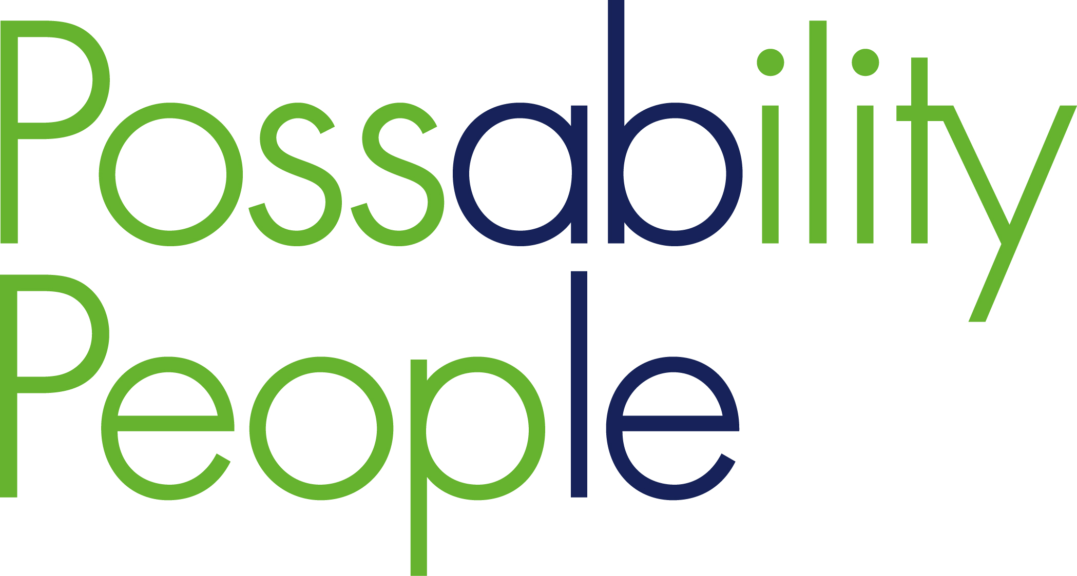

Equality Monitoring Form

To assist us with the equality monitoring of our service, please answer the questions below by ticking the appropriate box about you or the person you are representing. This information is confidential. If you require this publication in an alternative format and/ or language, please contact us to discuss your needs. This form is available to download from our website: www.possabilitypeople.org.uk

1. How old are you? …………….
2. Are your day to day activities limited due to being a disabled person?
Yes – A little |  | Yes – A lot |  | No
If YES please state your type of impairment (tick all that apply)
Physical |  | Sensory |  | Learning
Mental Health |  | Long standing illness |  | Developmental Condition
Other:

………………………………………………………………………………………………………………..
If you wish, you may say more about your disability, and what adjustments we might need to make in order to allow you to make the best use of our services:

3. Are you a Carer?
Yes |  | No
If YES who do you care for?

Parent |  | Child |  | Other family member
Partner/ Spouse |  | Friend |  | Other:  ……………………………………

4. Sexual Orientation
Heterosexual (straight) |  | Gay Man |  | Other:
Lesbian (Gay Woman) |  | Bisexual |  | Other:

5. What’s your Gender?
Female |  | Male |  | Other  ……………………………………
Do you identify as the gender you were assigned at birth? |  | Yes |  | No

6. What is your Religion/ Belief?
Buddhist |  | Muslim |  | Humanistic
Christian |  | Pagan |  | None
Hindu |  | Sikh |  | Other:  (Please State)
Jain |  | Agnostic
Jewish |  | Atheist

7. How would you describe Ethnic Origin?
English/ Welsh/ Scottish/ Northern Irish/ British |  | Caribbean |  | Chinese
Irish |  | Bangladeshi |  | Arab
Gypsy or Irish Traveller |  | Indian |  | Asian & White
African |  | Pakistani |  | Black African & White
Black Caribbean & white |  | Any other white back-ground  ………………………………… |  | Any other black back-ground  ……………………………………
Any other Asian back-ground  ………………………………….. |  | Any other mixed back-ground  ………………………………… |  | Any other ethnic group  ……………………………………

8. Armed Forces Service
Are you currently serving in the UK Armed Forces? | Yes |  | No
Have you ever served in the UK Armed Forces? | Yes |  | No
Are you a member of a current service persons immediate family? | Yes |  | No

9. Do you have access to the internet
Yes |  | No

