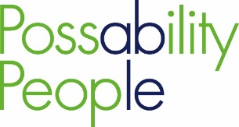
Our Vision A society where anything is possible regardless of ability
Our Mission We give people access to the right information with the right support to enable personal choice
Strategic Aim |  | Value Outcome | Objectives
1 | To improve accessible services | Access  People are accessing the personalised services they need | - To co-design services
 |  |  | - To make use of digital technology
 |  |  | - To make our services available in other locations and across communities
2 | To ensure people have good quality accessible information | Information  People are making informed choices | - To communicate options and offer realistic choices
 |  |  | - To produce user friendly materials
 |  |  | - To achieve and maintain appropriate quality standards
3 | To enable people to live more independently | Support  People are enjoying improved health & well-being | - To help join up services across all sectors
 |  |  | - To help and encourage people to take part in community life and work
 |  |  | - To offer and champion a range of accessible volunteering opportunities
4 | To increase the range of options people have | Choices  People have the possibility to choose | - To expand and develop services
 |  |  | - To raise awareness of what's out there
 |  |  | - To facilitate partnership working
5 | To have well trained and knowledgeable staff and volunteer teams | Ability  People are supported by a passionate and committed staff & volunteer team | - To work to Possability People’s vision and mission
 |  |  | - To commit to learning and developing in their own work
 |  |  | - To be self-aware and regularly reflect on own work

