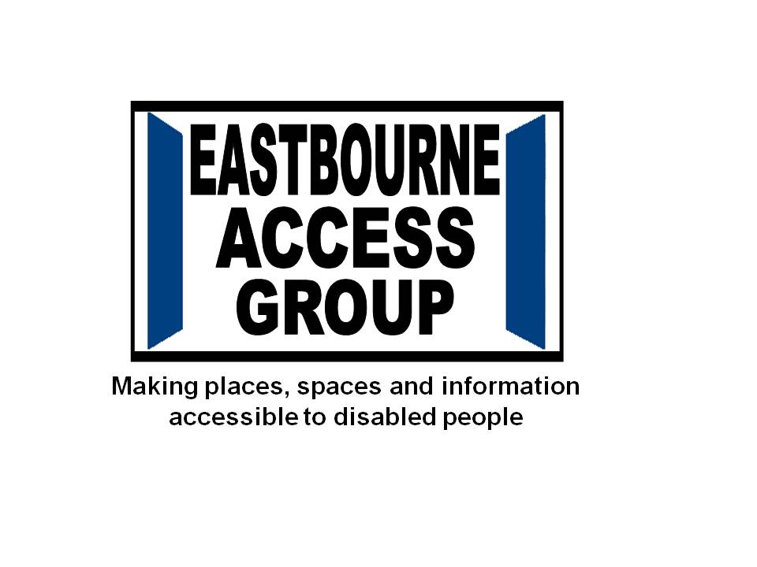

The Eastbourne Access Group was founded in 1981 to work with local statutory and voluntary organisations to challenge the barriers gaining access to public and private/business services and the local environment for disabled adults, children, their families and carers. The Access Group welcomes as members disabled people living with any impairment or disability.

**EASTBOURNE ACCESS GROUP CHAIR**

**Role Description**

* Chairing and facilitating the group meetings to ensure all members and guests are listened to and involved in the meetings in a respectful manner
* Liaising with the Treasurer to maintain an update of the group’s financial position
* Representing the organisation at appropriate events, meetings or functions.
* Acting as a spokesperson for the organisation where appropriate.
* Attending other voluntary group meetings or working groups when appropriate in role as Chair

**Qualities of a Chair**

* Commitment to the aims and direction of the Access Group
* Ability to support and facilitate the group members to good communication skills
* Tact and diplomacy.
* Willingness to speak one’s mind and listen to the views of others.
* An ability to work effectively as a member of a team.

**Essential experience**

* Lived experience of being a disabled person (any impairment) **OR** as a carer, friend or family member of someone living with an impairment/disability
* Appreciation of the challenges and barriers to access faced by disabled people, their carers and families.

**Desirable experience**

* Prior experience of being involved in a charity or voluntary group

**Time Commitment**

* The group currently meets monthly in an accessible location with parking, near to a bus route and the train station
* From time to time, the Chair might need to be available to attend and represent the group at local events, meetings or functions in the day and evening times.

This role is not remunerated but reasonable out of pocket expenses incurred fulfilling the duties of the role are reimbursed.

For an informal discussion about the role please get in touch by emailing [info@eastbourneaccessgroup.org.uk](mailto:info@eastbourneaccessgroup.org.uk) or text/phone 07810 317 185