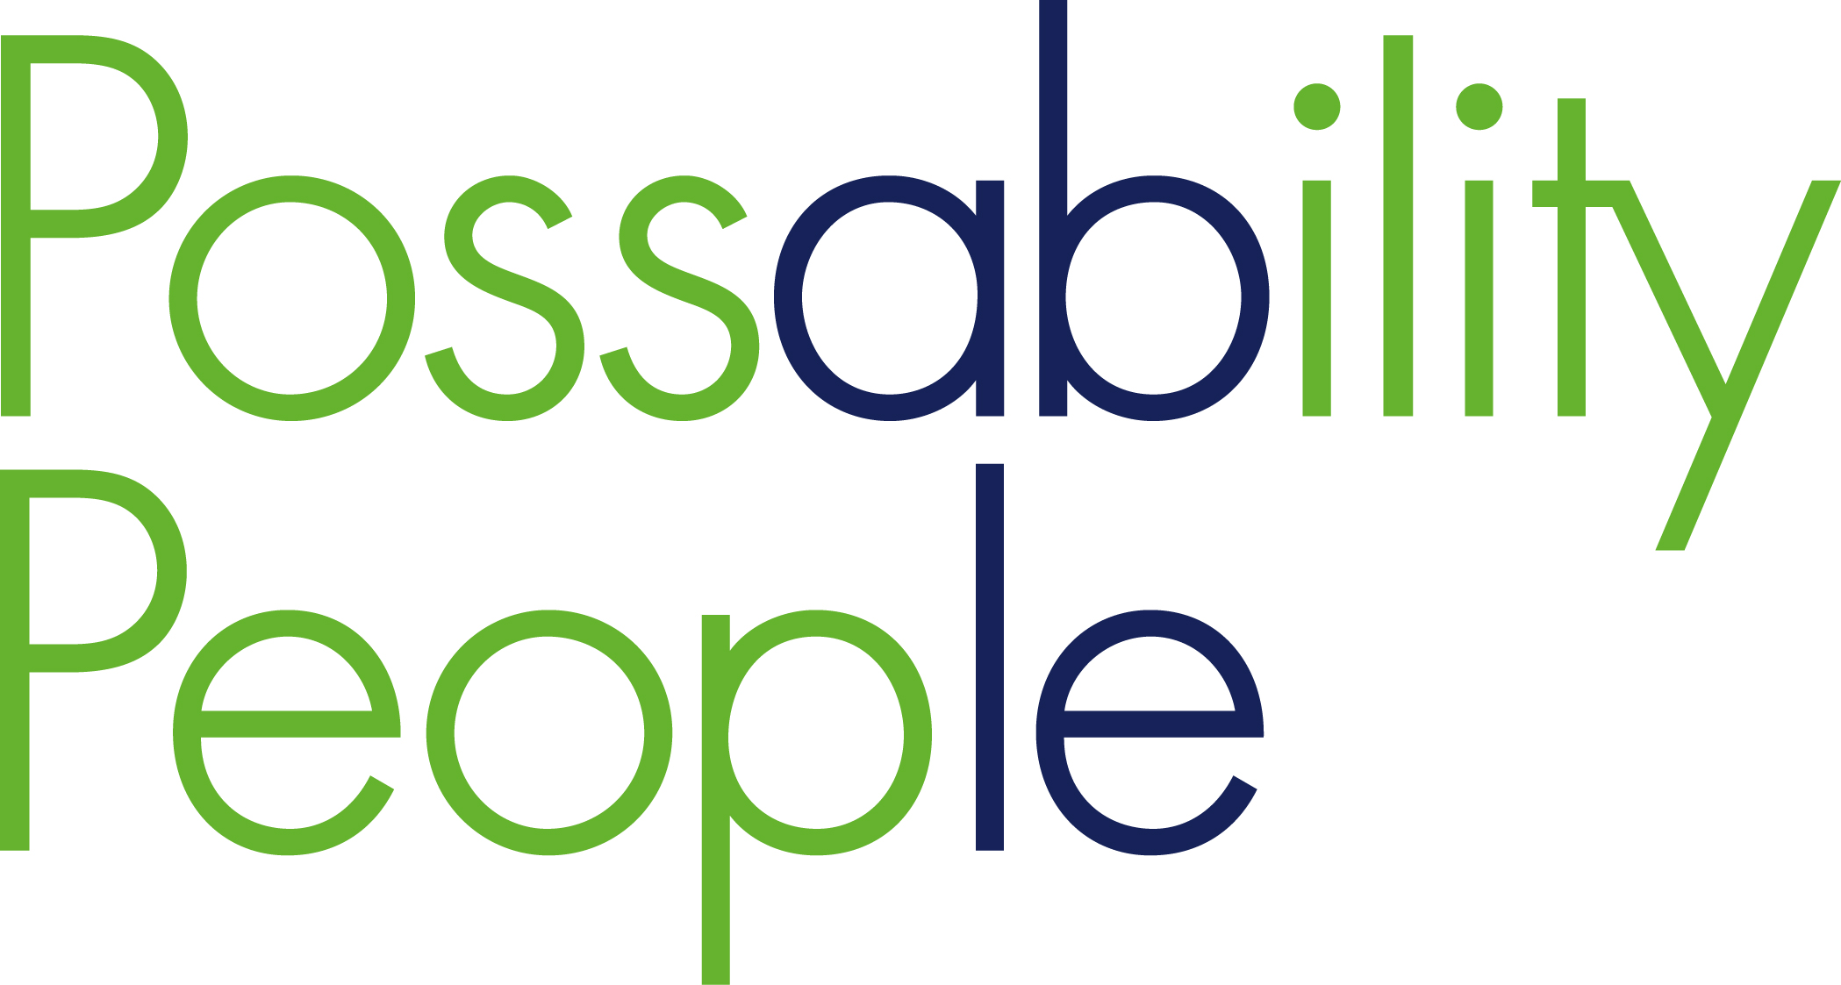
Membership Application pack

Dear Sir/Madam

Thank you for your interest in Possability People. Membership of Possability People is FREE

Possability People is a user-led organisation which promotes the Social Model of Disability as its underlying principle. In order to become a member applicants must sign up to our membership code and also show a commitment towards achieving Possability People objectives of being a leading service provider and influencer of other service providers and decision makers in Brighton and Hove.

Possability People seeks to achieve equality of opportunity and to this end membership is open to all sections of the Community, both disabled and non-disabled people, regardless of colour, race, religion, nationality, ethnic origins, gender, age or sexuality.

Possability People is keen to ensure that its membership is representative of the communities it serves, therefore welcome applications for membership from:-
- People using Possability People services
- Disabled people
- Individuals who have experience of disability
- Possability People also welcomes applications for membership from those who have a personal or professional capacity experience of disability services and rights

Please return the completed form to: Possability People, Montague House, Montague Place, Brighton, East Sussex, BN2 1JE or email hello@possabilitypeople.org.uk

I hope that together, we can forge closer links and work to promote choice and control for all disabled people in the city.

Yours sincerely
Geraldine DesMoulins
Chief Officer
Application Form - Organisation

Name the organisation you are representing:
Job Title/ Role in Organisation:
Organisations registered address:
Full Name:
Email: (our preferred method of communication with members)
If you cannot receive information by email please indicate here:
Website (if applicable):
Contact Number:
What are your interests in becoming a member of Possability People?
Would you like a volunteer application pack?
Are you a disabled person?
If you wish to be included on the websites membership directory, please describe your organisation: (no more than 50 words)
Please indicate if you do not wish for your details to be passed to a third party.
I agree to support the aims of Possability People, to abide by Possability People’s equal opportunities policies and to not do anything that brings Possability People into disrepute. | Name:  Signed:  Date:
Signature of the chair/ company secretary:  Role in Organisation: (Please indicate)  Chair Company Secretary | Name:  Signed:  Date:

Application Form – Individuals

Full Name:
Job Title (if applicable):
Email: (our preferred method of communication with members)
If you cannot receive information by email please indicate here:
Website (if applicable):
Contact Number:
What are your interests in becoming a member of Possability People?

Would you like a volunteer application pack?
Are you a disabled person?
Please indicate if you do not wish for your details to be passed to a third party.
I agree to support the aims of Possability People, to abide by Possability People’s equal opportunities policies and to not do anything that brings Possability People into disrepute. | Name:  Signed:  Date:

Membership Policy

Objective of the Policy

This policy aims to promote the good governance of Possability People and to ensure the proper accountability of its Board of Management by having a membership which is as wide as possible, subject to the criteria detailed below. It is intended that Members should be at the centre of the organisation and empowered to participate in and contribute to the wider life of Possability People.

Promotion of Membership

Possability People will promote membership opportunities through the Annual Report, newsletters, services and public meetings, dissemination of promotional material where appropriate, by invitations to relevant organisations and individuals with a background in an appropriate profession or discipline, or with a community of interest with Possability People.

Membership Criteria

Possability People seeks to achieve equality of opportunity and to this end membership is open to all sections of the Community regardless of colour, race, nationality, ethnic origins, gender, disability, age or sexuality. Applications for membership are particularly welcomed from:-
Black and ethnic minority community members.

Possability People seeks a balanced representative membership, with no particular group having an undue influence, and comprising persons who have in a personal or professional capacity the requisite knowledge, skills and experience, or a community of interest in the services for people with a disability. A commitment is required towards achieving Possability People’s objective of being a leading service provider and influencer on other service providers and decision makers in Brighton and Hove. Possability People is keen to ensure that its membership is representative of the communities it serves, therefore we will particularly welcome applications for membership from:-

- People using Possability People services
- Disabled people
- Individuals who have experience of disability
- The Association also welcomes applications for membership from those who have a personal or professional capacity experience of disability services and rights

Membership is open to individuals and nominees of unincorporated bodies, societies, companies and local authorities. A corporate body may appoint a deputy to exercise its rights and powers at any general meeting.

Members’ Responsibilities

The primary role of the Member is to advance the good governance of Possability People and to ensure that the Board of Management is accountable for its acts or omissions. Members’ powers are usually exercised at general meetings, namely: the receipt of the Annual Accounts and Balance Sheet; the appointment of the Auditor; the election of the Board; the application of surpluses for particular purposes; amendment of the Rules, and dissolution of Possability People. In addition, the requisite number of members may apply to the Registrar to: appoint an Accountant or Actuary to inspect Possability People books; appoint an Inspector to report on the affairs of Possability People; or to call a Special General Meeting.

Member Participation

Members are entitled to be present and vote at any General Meeting of the association. Members are given at least 21 days notice of such meetings. Members receive a copy of Possability People’s Annual Report and Accounts. Members are entitled to receive, on request, a copy of the Annual Return to the Charities Commission.

Applications for Membership

An application form can be obtained from the Secretary of Possability People at the address below. Completed applications should be forwarded to the Secretary at the same address. Every application for membership will be considered by the Board at its next meeting, or so soon thereafter as is practicable.

An application for membership will only be approved where in the Board’s sole opinion an Applicant meets the criteria set out above and where admission to membership is within Possability People Rules and would advance Possability People’s objective of having a balanced and representative membership, such that no particular group has undue influence. A people using the services of Possability People will normally be considered to part of the relevant community of interest.

If the application is approved the applicant will be advised in writing within 14 days of the date of the decision. At the same time the applicant will receive a Membership Certificate, a copy of Possability People Rules and details of how Members can participate in the life of Possability People.

Where an application is unsuccessful, a written statement of the reasons for refusal will be given to the applicant within 14 days of the date of the decision. An applicant may appeal against the decision within 14 days of receipt of the statement of reasons by notice in writing to the Secretary of Possability People. In exceptional circumstances, the Board at its discretion may consider an appeal that is not in writing. The Board shall consider the appeal at its next meeting or so soon thereafter as is practicable. Intimation of the Board’s final decision, together with a written statement of reasons for refusal if relevant, will be given to the applicant within 14 days of the date of the final decision.

Termination of Membership

A Member shall cease to be a Member if he or she

(i) dies; or
(ii) in the case of a body corporate ceases to be a body corporate; or
(iii) is expelled; or
(iv) non payment of annual membership fee; or
withdraws from Possability People; or
(vi) in the case of a nominee of an unincorporated body, transfers his or her share to another nominee

The membership fee will not be refundable on termination of membership but will become the property of Possability People. The Trustees reserve the right to review the membership of any individual(s) who operate outside of the spirit of this code and the values of Possability People.

Review of Policy

The effectiveness of the policy will be monitored annually by the Board, to ensure that the objectives are being met. The policy will be reviewed every 3 years

Code of Conduct

Background

Possability People works to three key principles -

Equality - seeking to positively promote fairness in every sphere of our activities - employment, member service provision, our place in the local community and as a role model to other voluntary agencies. We question all attitudes, which do not appear to support our ethos, and seek to bring about change wherever we can.

Social Model of Disability - Turning the focus away from the functional limitations of our bodies and minds and towards the disabling barriers of unequal access, prejudice, discrimination, and social exclusion that cause disability.

Representation and Accountability – where members are elected, requested or otherwise to represent the organisation they must represent the broad interest of Possability People, not their personal or own organisation’s view

Basic Principles

All members are required to uphold Possability People’s policy and practice and to actively enjoy and promote the organisations activities within the law.

1. Equality

1.1 Possability People is committed to the principles of respecting diversity and equal opportunity for all, ensuring that there is no direct or indirect discrimination within the organisation. This applies to all, members, Trustees, service users, volunteers, employees, contractors and temporary staff. All workers must accept personal responsibility for fostering and maintaining a fully integrated and harmonious community on Possability People’s premises.

Our policy aims to ensure that no-one coming into contact with Possability People personnel, on or off the premises, receives less favorable treatment on the grounds of race, gender, sexual orientation, physical or mental disability, religious, cultural or political beliefs, creed, nationality or marital/parental status (direct discrimination). We also believe that no one should be treated less favorably on the basis of age.

All members are expected to uphold and promote the Equal Opportunities Statement and Policy of Possability People. See Equal Opportunities Statement and Policy for full details

Social Model of Disability

All members are expected to support Possability People’s commitment to and adoption of the social model of disability in all its activity and work.

From time to time Possability People will hold opportunities for members to discus and debate the issues that the social model raises for disabled people.

Representation and Accountability

In order that Possability People members and partner agencies have full confidence in our representation processes, the following guidelines apply:
- Representatives must represent the broad interest of Possability People and its members, not their personal or own organisation’s view.

- Representatives will work to promote Possability People values.

- When reporting back about meetings, members/representatives will report the same views, information and input they gave when at the meeting.

General Ground Rules

As a member of the Community and Voluntary Sector Forum (CVSF) Possability People adopts the following ground rules -

- Allow people to disagree
- Challenge the issue not the person
- Confidentiality: in general, members may leave the meeting and repeat what was said, but not who said it
- Confidentiality: people may raise specific issues and ask for them to be kept within the group. Let the scribe know if you don't want it noted (notes on flipcharts are public)
- Depending on your group you may wish to agree on less swearing than usual!
- Don't interrupt each other
- Do encourage participation
- Mobile phones off
- No jargon
- No language which could be construed as discriminatory or is offensive to others
- Do not use your status to undermine others
- Treat each other with respect

How will the code be upheld?

The Board of Trustees will be responsible for establishing and reviewing regulations and procedures governing the code. The Trustees issue the following guidance:

An allegation of misconduct from any party which comes to the attention of Possability People shall be dealt with in accordance with the following guidelines and in line with Possability People Complaints Procedure. All proceedings will be dealt with confidentially until the final decision is made:

- All parties should try and resolve the complaint at the earliest possible stage.
- Each stage of the complaints procedure must be sufficiently exhausted before proceeding to the next stage.
- The Chief Officer of Possability People is responsible for ensuring the complaint is dealt with in accordance to the procedures below:

Possability People shall not be obliged to investigate (i) if the allegation is made anonymously, (ii) if the alleged incident(s) occurred more than one year prior to the allegation and (iii) if the complaint does not specifically relate to a breach of Possability People’s Code of Conduct.

The Trustee may elect to engage an outside facilitator to assist in the procedure.

The Trustees reserve the right to review the membership of any individual(s) who operate outside of the spirit of this code and the values of Possability People.

Social Model of Disability

The work of Possability People is based on the social model of disability, which emphasises that disabled people are disabled not by limitations of our bodies and minds but by social barriers of unequal access, prejudice, discrimination, and social exclusion.
"The disabled people's movement in Britain uses the term "disability" not to mean impairment but to refer to the disabling barriers of prejudice, discrimination, and social exclusion" - Jenny Morris 1988.
Separating out "impairment" (that is, the functional limitations of bodies and minds) from "disability" (that is, the disabling barriers of unequal access and negative attitudes) is the cornerstone of what is known as the social model of disability. This has enabled disabled people to challenge the assumption that impairment is an inevitable tragedy which can only be alleviated by cure or death.
The quality of disabled peoples lives, and life chances, are not inevitably determined by what peoples bodies can't do, or look like, or how minds function. We therefore need to separate out "impairment"—the characteristics of our bodies and minds—from the way other people and society generally react to impairment.
Prejudice, discrimination, services which disempower and segregate us; a failure to use resources to create accessible environments, to use technology to aid communication, to provide personal assistance to aid daily living, and so on—these are the disabling barriers that disabled people experience.
People with physical, sensory, and cognitive impairments, and people with mental health problems, are therefore disabled by the society in which we live. We therefore use the term "disabled people" to describe what is done to them.
This language takes the focus away from impairments being the problem and puts the responsibility onto the society in which we live.

